An Efficient Virtual Machine Intrusion Detection System on
Cloud Computing
ABSTRACT
As Cloud Computing is the rapidly growing field of IT. Cloud Computing is defined as an Internet based computing in which virtually shared servers that is data centers provide software, platform, infrastructure, policies and many resources. In this research we have analyzed, the various intrusion log files of virtual machines in order to identify the significant features for creation of intrusion model. In this research we have used logistic regression classification algorithm. Through this algorithm we have achieved the highest accuracies with low false positive rate
Existing System
Cloud computing is a knowledge which everything only on the internet; central distant servers are used to sustain data and applications [2]. Cloud computing permits the users to use applications deprived of installing software’s. The users can admission the internet and send messages wherever in the world. Cloud computing permits more well-organized computing by central storage, memory, dispensation and bandwidth. The greatest example is Google mail. For this, the users essential not install any software or a server to use a Google mail explanation. The user can admission internet, over which he sends message
Disadvantages
- the users essential not install any software
- Provider has no responsibility on the intrusion detection mechanism.
Proposed System
In this research we have analyzed, the various intrusion log files of virtual machines in order to identify the significant features for creation of intrusion model. In this research we have used logistic regression classification algorithm. Through this algorithm we have achieved the highest accuracies with low false positive rate.
Advantages
- Cloud computing permits the users to use applications deprived of installing software’s.
- The users can admission the internet and send messages wherever in the world
System Architecture

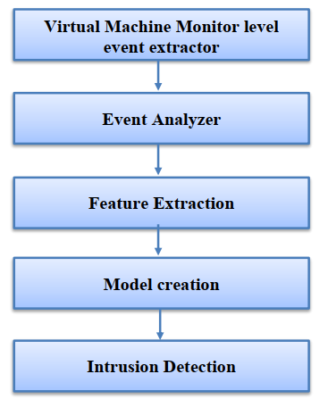
Figure 1: Proposed Intrusion detection system
framework

Hardware Requirements:

Processor - Pentium –IV
- Speed - 1.1 GHz
- Ram - 256 MB
- Hard Disk - 20 GB
- Key Board - Standard Windows Keyboard
- Mouse - Two or Three Button Mouse
- Monitor - SVGA
Software Requirements:
- Operating System - Windows XP
- Coding Language - Java

